|  |
| --- |
| **MINISTRY OF EDUCATION AND TRAINING**  **HO CHI MINH CITY UNIVERSITY OF TECHNOLOGY AND EDUCATION**  **FACULTY OF HIGH QUALITY TRAINING**  -----🙞🙜🕮🙞🙜----- |

|  |
| --- |
| **FINAL-TERM REPORT (SUMMARY)**  **ARTIFICIAL INTELLIGENCE**  **LANGUAGE DETECTION (CNN MODEL)** |
|  |

|  |
| --- |
| **Lecturer:**  **MSc Nguyen Truong Thinh**  **SVE: Nguyen Ngoc Quy**  **Major:** **Mechatronics Engineering**  **ID: 20146056** |

|  |
| --- |
| **Ho Chi Minh City, May 26, 2023** |



**LANGUAGE DETECTION**

This report introduces the important role of language detection in text classification and cross-cultural communication. Using Convolutional Neural Networks (CNNs), we propose building an intelligent language detection system capable of accurately identifying and classifying different languages based on textual inputs. By combining theoretical knowledge with practical implementation, our goal is to develop a user-friendly application that allows users to easily identify the language of any text, regardless of its origin or complexity.

Our research methodology includes data loading, data splitting into training and test sets, CNN model construction, data augmentation, model training and evaluation. By applying these steps, our language detection system effectively classifies text into different languages with accuracy, enabling various language-related applications.

This report holds significant importance in the development of natural language processing technology. By building an accurate and user-friendly language detection system, we contribute to this field and open up potential future advancements.

**Results of Language Detection**

1. **Results of detection language with thinker load data.**

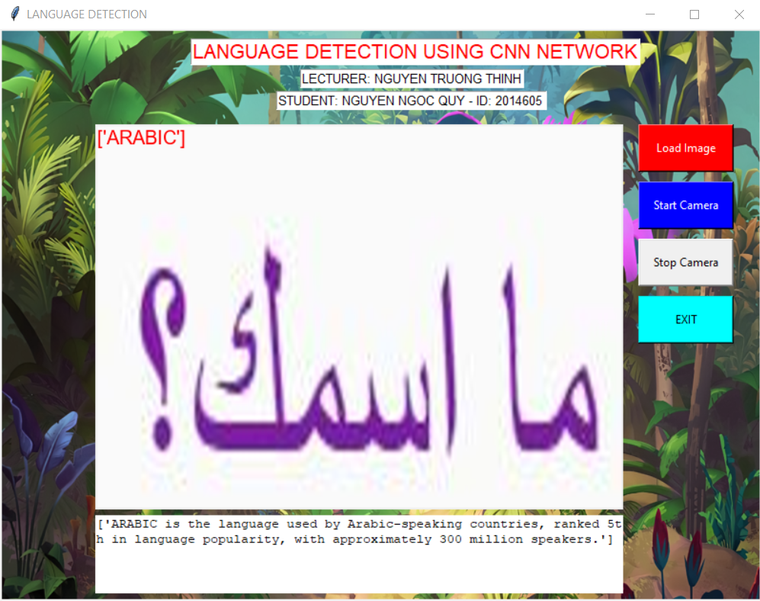



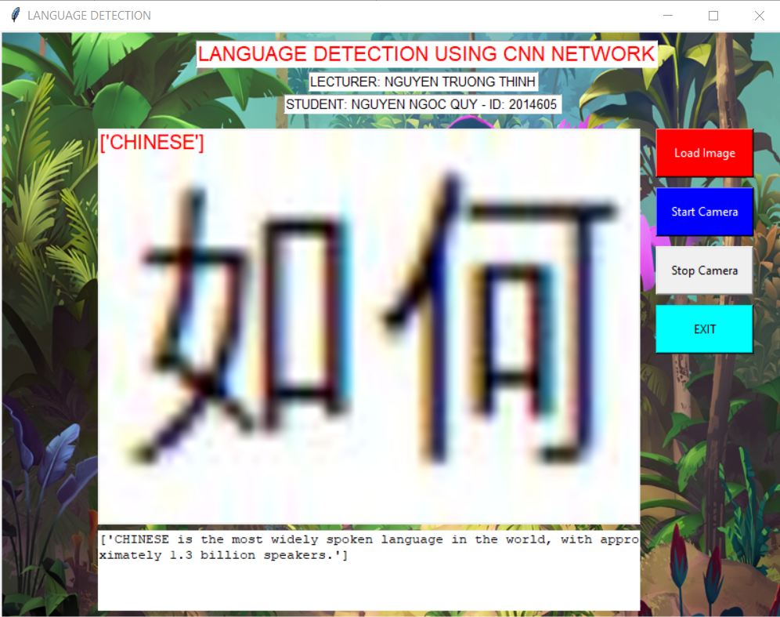

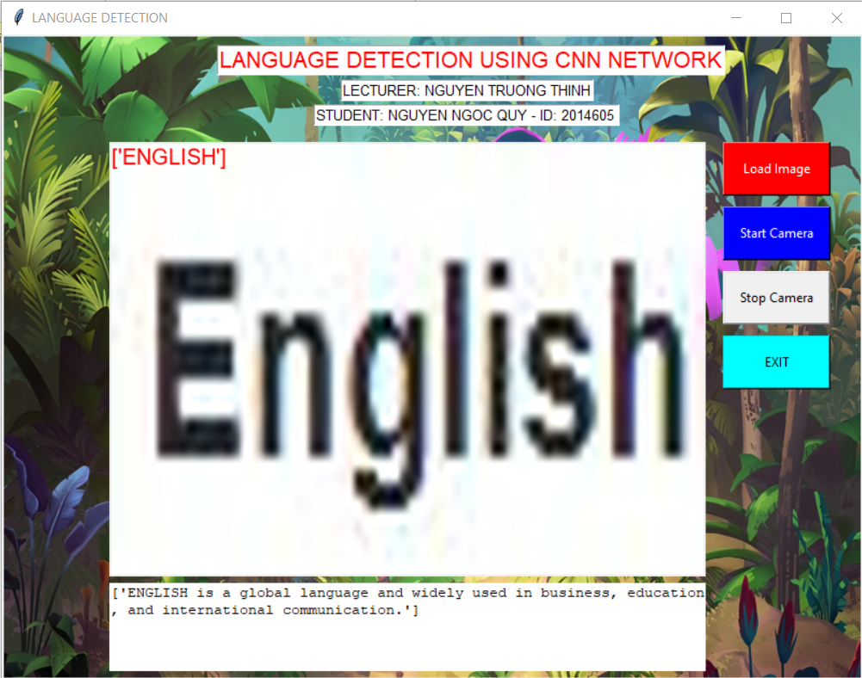

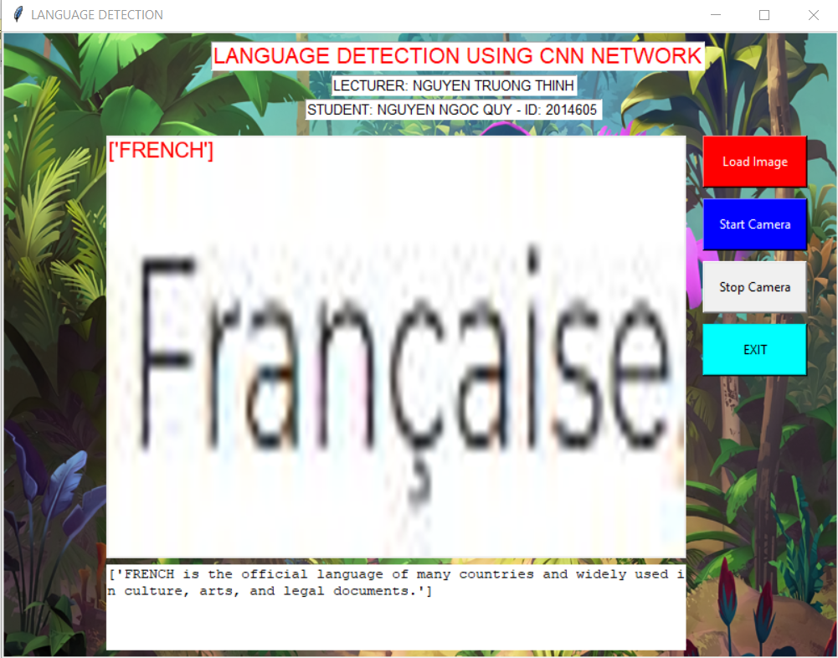

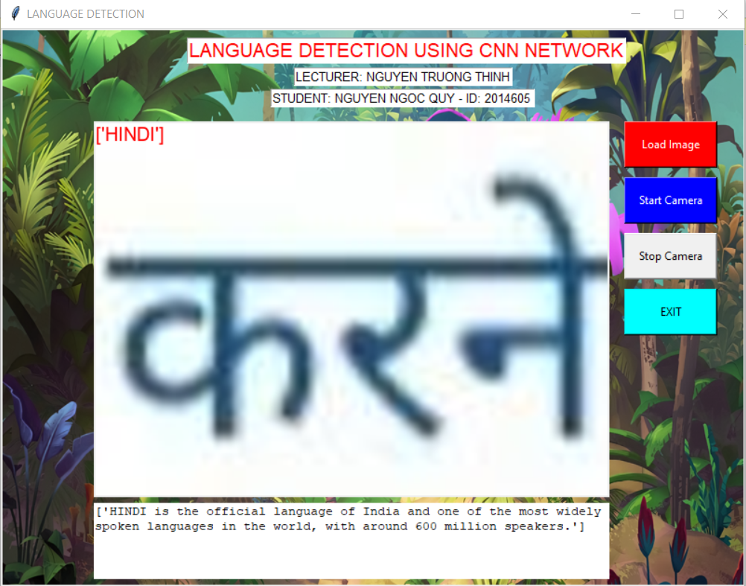

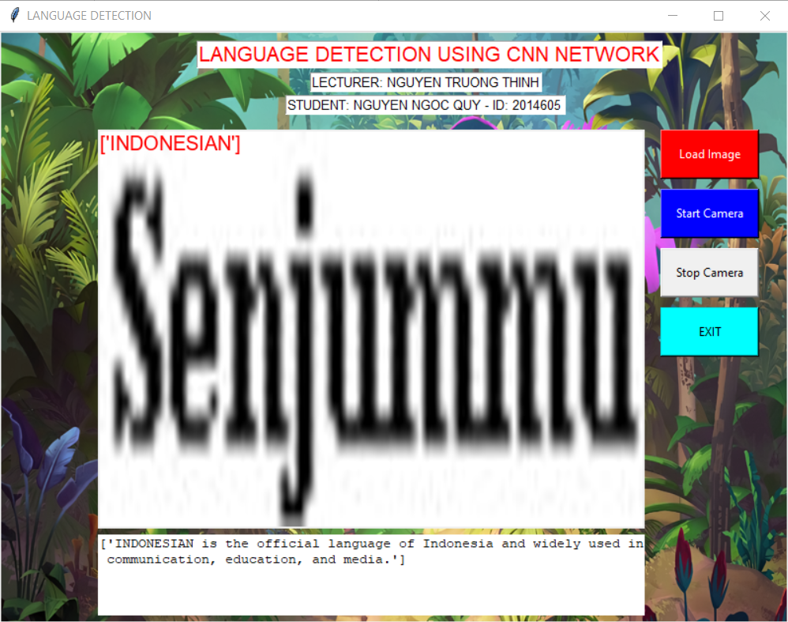

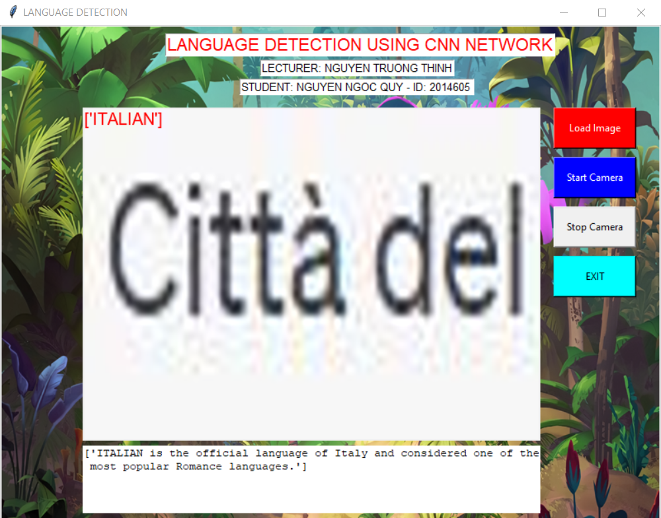

1. **Results of detection language with thinker RealTime.**

